**World Robotics Olympiad**

Future Engineers Challenges

Self-driving Autonomous Car: Time attack and Obstacle Avoidance

**Team Brainiacs**

Coach: Wassim Ghaddar

Team members:

1. Hassan Harb
2. Mahmoud Mustapha

12/7/2024

**Introduction**

Team Brainiacs has developed a self-driving autonomous car for the 2024 WRO future engineers’ competition. This car uses the principles of computer vision and PID to complete the specified rounds of this challenge. The car uses PID to control its movement and steering while using a color sensor to detect the corners of the playfield and turn accordingly. Moreover, computer vision was implemented using a Raspberry PI 5 and raspberry Logitech C270 camera to detect the traffic signs and steer the car to complete the whole track.

The self-driving race car's code involves several key modules. A Raspberry Pi 5 runs computer vision algorithms to detect obstacles using camera data. Arduino Uno modules control the car's motors, servos, and sensors for movement and navigation. An MPU6050 gyroscope sensor ensures the car stays centered and stable while driving. Additionally, a TCS34725 color sensor detects environmental colors to aid in navigation and turning.

Our team’s work was based on the popular saying “ one hand can’t clap alone”. With the coach’s help and monitor the members could perfectly work by distributing work. Together Hassan and Mahmoud worked on the connection diagram and code writing. For processing the computer vision to detect the traffic signs, the coach was able to teach the members how to be working in such an advanced level. As a result of this great work, the brainiacs team perfectly managed to perform a self-driving robot applicable with all rules provided for the competition.

**Project Idea**

This self-driving car was established to be moving on a random lane according to the judges’ choice. The car must complete three rounds, an open round where it must complete 3 perfect turns on the lane chosen by the judge, the car during its turns would detect colored stripes on the 90 degree turn to either turn left (detecting orange color) where it moves clockwise or turn to the right (detecting blue color) where it moves in a counter clockwise motion. This challenge has a 3-minute max. time duration for the car to cover the whole 3 turns.

In the second challenge obstacles must be detected and avoided by the car. The car must detect traffic signs and avoid them. The self-driving car must pass the red pillar from the right and the green pillar from the left without moving or knocking down the obstacles outside the circular border drawn around them.

The self-driving car must also perform a parallel parking in a lot 1.25 times the size of the car.

The project by performing these challenges in a small scale and passing them in a perfect manner could be performed in bigger scales to make all vehicles in the market as in our project. Develop an autonomous vehicle capable of navigating urban environments to perform all human purposes from transportation to delivery. Such an idea is performed using computer vision for obstacle detection using raspberry pi 5 and Arduino scripts to analyze and compute data to perform various stability and motion control through the different sensors, actuators, and devices.

**Robotic Solution**

**Materials used:**

* Raspberry Pi 5 8gb
* Arduino UNO R3
* GY-87 gyroscope
* Adafruit TCS34725 color sensor
* Logitech C270 720p30 webcam
* 1 High Speed DC motor
* 1 Mg995 geared servo motor
* 4x 4800mAh Lithium-Ion battery 18650 sticks
* L298N Dual H-bridge Motor controller
* Auxiliary 3D printed parts and laser cut chassis
* Power bank 10000mAh
* Switch module
* Tactile Push Button
* LM2596S Step-down buck converter

**Programming Languages Used**

* Arduino C++
* Python

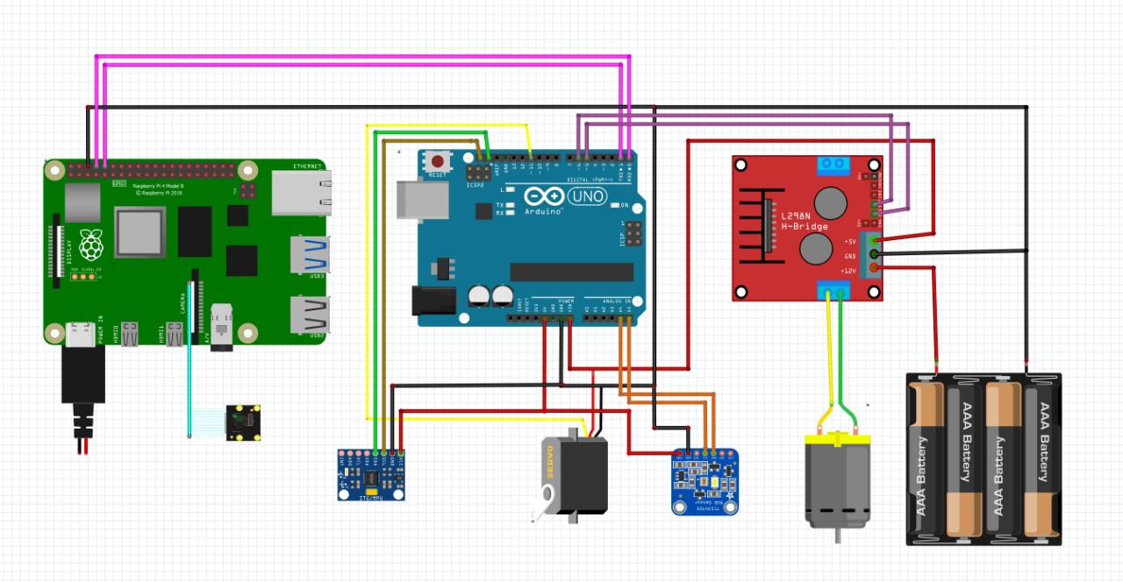**Schematic Diagrams**

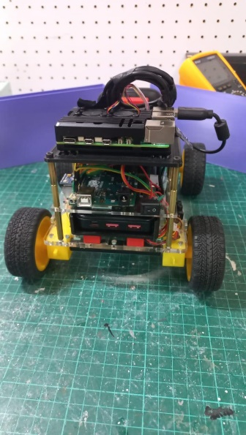**Pictures of The Robot**

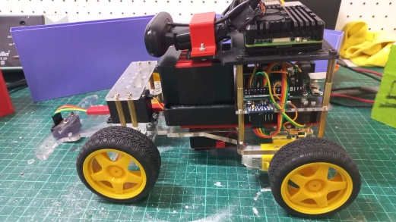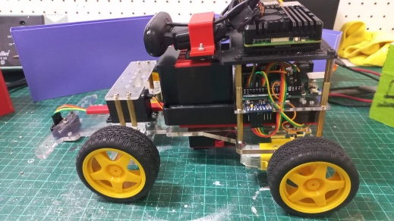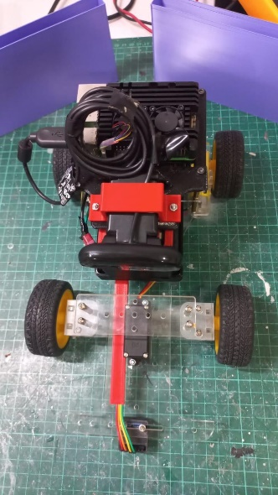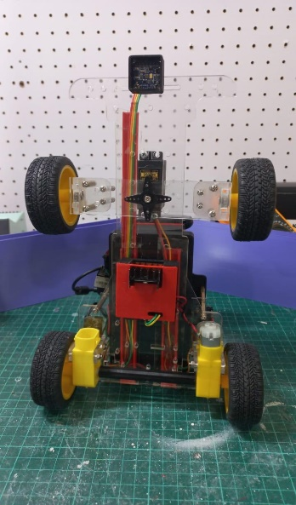

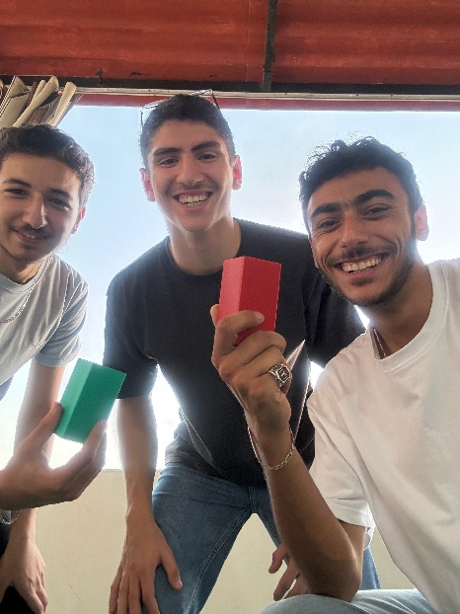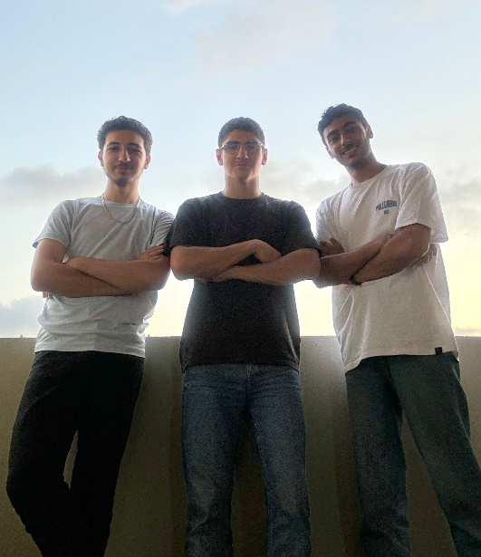**Team Pictures**